**Thomas Flynn**

**G00291875**

**25/10/15**

**Sprint 1: Week 2 Log**

This week I received feedback from my Supervisor on how to adjust the scope of my project.

I was advised to remove some of the features I suggested in the project proposal.

I have removed both the Arduino and the FPGA DSP hardware features from Trello Project management system.

**Board adjustments**

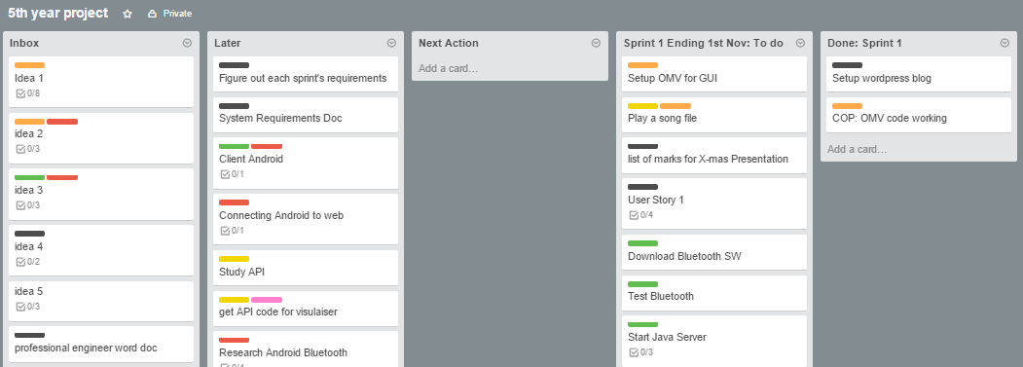

**Updated labels with features removed:**

